
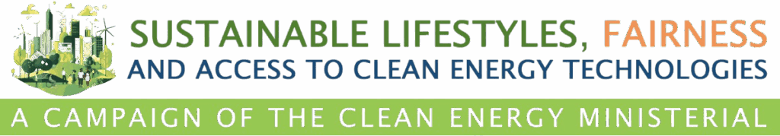

Sustainable Lifestyles, Fairness and Access
to Clean Energy Technologies Campaign

Awards Submission Form
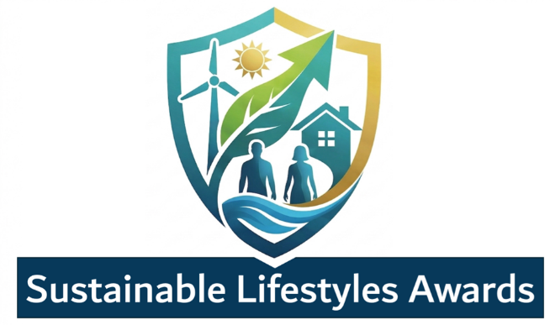

2026

in partnership with
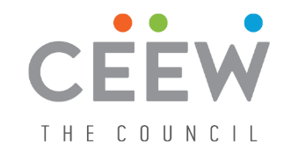

Awards Submission
Please read the entire application before beginning to complete this form. Please confine responses to the space allowed. If additional space is needed to provide further explanation, evidence of claims, references, and/or attachments, please use the supplemental document.
Forms should be submitted by email to: secretariat@CEMSecretariat.org, with subject: Sustainable Lifestyles Awards Entry | <Country Name>
The Official Rules and other information related to the Sustainable Lifestyles Awards competition can be found online here.

SECTION A: General Information
Project/Initiative Title: Click or tap here to enter text.
Lead Organisation: Click or tap here to enter text.
Partner Organisations (if applicable): Click or tap here to enter text.
Project/Initiative Location: Click or tap here to enter text.
Time Period of Project/Initiative: Click or tap here to enter text.
Link to Project Website (if available): Click or tap here to enter text.
Awards Category: Choose an item.

Section B: Category-specific Information
Please complete ONLY the section that corresponds to your selected category.
Category 1: Policy – Leading by Acting
Focus: Incentives, Regulations, Awareness Campaigns

- Policy Description: Describe the specific regulation, incentive, or campaign implemented. What was the objective identified for the same? (Max 300 words)
Click or tap here to enter text.

- Behavioural Shift: How has this action made sustainable choices the "easy" or "default" choice for the target audience? (Max 200 words)
Click or tap here to enter text.

- Fairness Aspect: What is the impact so far, and/or the possible impact of the policy? How does this action ensure fairness and affordability for local communities, including in vulnerable situations/underrepresented community? (Max 200 words)
Click or tap here to enter text.

Category 2: People – Empowering Individuals & Communities
Focus Area: Education, Local Leadership, Inclusion, Resource Equity

- Empowerment Narrative: Describe the project/initiative objective and its implementation. How did this project/initiative involve local communities, women, or youth in the transition? (Max 300 words)
Click or tap here to enter text.

- Skill Building: What educational or training resources were provided to cultivate a sustainable future? (Max 200 words)
Click or tap here to enter text.

- Local Impact: What impact was created? Share measurable insights and provide evidence of how local authorities or social partners were empowered through this initiative. (Max 200 words)
Click or tap here to enter text.

Category 3: Sector – Transforming Systems
Focus Area: Clean Buildings, Mobility, Low carbon technology, Circular Economy
- Systemic Shift: Describe the specific technological or structural change implemented, and the objective behind the same? (e.g., low-emission mobility , circular economy, low emission technology or clean cooking). (Max 300 words)
Click or tap here to enter text.

- Resource Efficiency: Provide data on energy/material savings or the advancement of circular practices. (Max 200 words)
Click or tap here to enter text.

- Accessibility: How has this systemic change improved affordability and access for the broader community? (Max 200 words)
Click or tap here to enter text.

Section C: Impact & Documentation (All Categories)
- Measurable Results: Provide up to three key KPIs (e.g., % reduction in waste, number of people trained, tonnes of CO2 avoided).
Click or tap here to enter text.

- Verifiability: Link to a public report, audit, or website.
Click or tap here to enter text.

- Supporting Materials: Upload up to 3 files (e.g. Photos, Case Study PDF, or 2-minute Video link).


Click or tap here to enter text.

SECTION D: Acceptance of Terms & Declaration
Please read the following carefully and sign below to complete your submission.
- Accuracy of Information: I hereby declare that all information provided in this application is true, accurate, and complete to the best of my knowledge.
- Authorization: I confirm that I am authorized to submit this nomination on behalf of my organization
- Use of Data & Media: I grant the Clean Energy Ministerial (CEM) and CEM Sustainable Lifestyles Campaign the non-exclusive right to use the provided project descriptions, data, and media (photos/videos) for promotional, educational, and reporting purposes.
- Ministerial Attendance (CEM17): In the event that this initiative/project is selected as a winner, a high-level representative from our organization will make every effort to attend the Awards Ceremony in person during the CEM17 Ministerial Meeting in Riyadh, Kingdom of Saudi Arabia, from 11–13 October 2026, to formally accept the awards.
- Verification: I understand that the Awards Secretariat may contact me for further verification of data or to request a brief interview/pitch if the project is shortlisted.
- Finality of Decision: I acknowledge that the decision of the Jury (CEM Co-Leads) is final and not subject to appeal.
I have read and agree to the terms and conditions stated above.

Full Name of Authorized Representative | Click or tap here to enter text.
Title / Position | Click or tap here to enter text.
Date | Click or tap to enter a date.
Signature (or Digital Signature) | Click or tap here to enter text.  __________________________________________

